CURRICULUM VITAE

Truptirekha Sahoo
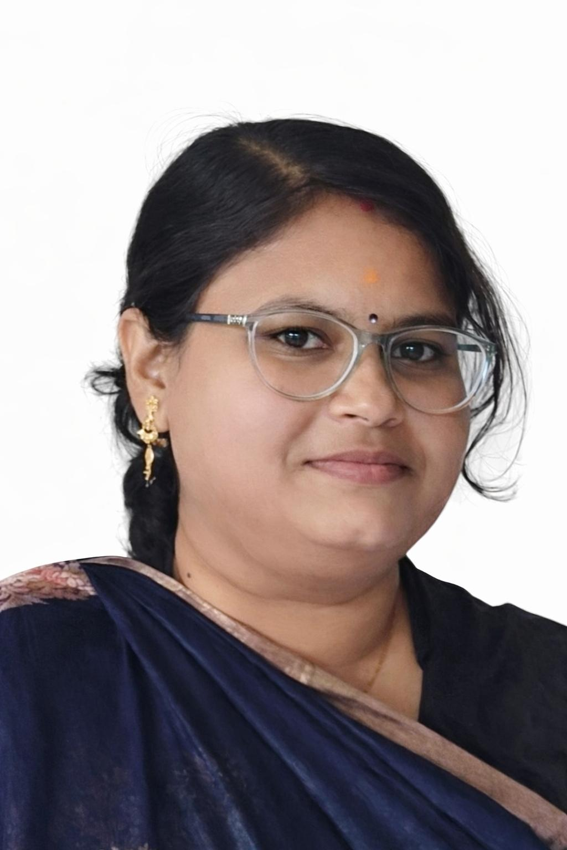
C/O- Narendra Nath Sahoo
Ward no-15, Bijaypurna Chandra Pur, Baripada
Odisha-757001
Contact Number: +91-8249576626, +91-9937039955
Email: sahootruptirekha28@gmail.com

Career Objectives:
Intend to build a career in academic sector in an energetic environment with dedicated and committed professionals where I can contribute to the University with my exceptional interpersonal, communication and teaching skills and my willingness to work as a passionate lecturer for student career building.
Current Position:
- Guest Faculty in History, Maharaja Sriram Chandra Bhanjadeo University, Baripada.

Educational Qualifications:

- Doctor of Philosophy in History (Ph.D), MSCB University, Baripada, Odisha (2023)
- Master of Philosophy in History (M.Phil) with First Division, North Orissa University, Baripada, Odisha (2011).
- Master of Arts in History (M.A.) with First Division, North Orissa University, Baripada, Odisha (2009).
- Graduation in History (Honours) with Second Division, Govt. Women’s Collage, Baripada, Odisha (2007).
- +2 Arts with Third Division, C.H.S.E, Orissa (2004).
- H.S.C. with Second Division, B.S.E, Orissa (2002).

Work Experience:

- Worked as a contractual lecturer in History for teaching both under graduate and intermediary students in Malyagiri Mahavidyalaya, Pallahara, Anugul from 2014 till 2016.
- Worked as guest faculty in History for teaching both under graduate and intermediary students in Nilakantheswar Degree Mahavidyalaya, South Balanda, Talcher from 2017 till 2019.
- Currently working as Guest Faculty in History for teaching Post Graduate Students in Maharaja Sriram Chandra Bhanjadeo University, Baripada from 2023 till now.

Articles & Journals Presented/Published:
- “Maharaja Sri Ramachandra Bhanja Deo: The Benevolent Ruler of Mayurbhanj”, The Researchers Volume VIII, Issue II, 15 July-2022, International Research Journal.
- “Fairs and festivals of Mayurbhanj: an Overview”, International Journal of Humanities Social Science and Management (IJHSSM), Volume II,Issue 5, Dec-2022, pp: 441-447.
- “A Case Study on Exclusive Tribal Festivals of Mayurbhanj”, International Journal of Humanities Social Science and Management (IJHSSM), Volume IV, Issue 2, Mar-2024, pp: 633-637
- “The Grandeur of Mayurbhanj Maharaja Krushna Chandra Bhanja Deo: A Guide to his Reign”, International Journal of Humanities and Social Science Invention (IJHSSI), Volume 13, Issue 10, October 2024, pp: 109-111.
- “Reviving Identity Through Script: A Study on Santali Language and Pandit Raghunath Murmu’s Contribution” JETIR, Volume 12, pp. D297- D302.
- “The Karam Tree and Its Socio-Ecological Significance Among Tribal Communities of Eastern and Central India”, JETIR, Volume 13, pp. A98- A100
- Presented paper on “ The evolution of Santali communication and the Legacy of Pandit Raghunath Murmu” at National Seminar on Socio-Economic and Cultural Profile of Tribes of North Odisha: Changing Through the Ages at MSCB University, Baripada (2025).
- Presented paper on “Merger of Mayurbhanj State with Odisha Province” in 44th Session of Odisha History Congress organized at Gangadhar Meher University (GMU), Sambalpur, Odisha (2025).
- Presented paper on “Cultural History of Mayurbhanj” in the technical session of the Regional Conference of Odisha History Congress at BB. College, Baiganabadia, Mayurbhanj (2021).
- Presented paper on “Netaji Subash Chandra: An Active Participant of Indian National Movement” in the national seminar organized at Luipa Degree College, Radho, Mayurbhanj (2016).
- Presented paper on “Maharaja Krushna Chandra Bhanja Deo: The prominent ruler of Mayurbhanj” in the national seminar organized at BB. College, Baiganabadia, Mayurbhanj (2016).
Books Published:
“Culture of Mayurbhanj Through the Ages A Study of Shifting Paradigms” by Kunal Books (2025), ISBN 978-93-6389-709-0.
Seminar/ Workshop Attended:
- PM-USHA Lecture Series: Indian Knowledge System in Curriculum Design (2025)
- Attended Regional Session of Odisha History Congress 2024, M.P.C. Auto. College, Takhatpur, Baripada (2024).
- Attended Regional session on Odisha History Congress at M.P.C. Autonomous College, Baripada, Mayurbhanj (2019).
- Attended UGC Sponsored teacher’s orientation and training programme on research methodology and its application in social science at M.P.C. Autonomous College, Baripada, Mayurbhanj (2013).

Membership:
Permanent member of Odisha History Congress from 2025.
Acted as a Guide for the dissertation work of P.G. Students:
- Mahatma Gandhi and His Contribution to Indian Freedom Struggle
- Socio Cultural and Economic Life of the Bathudi of Mayurbhanj
- Historical Background of Sati Pratha in India
- Cultural Achievements During the Mughal Age
- Impact of Gandhi and Philosophy in Indian National Movement
Skills:
- Classroom teaching & student engagement
- Discussion-based pedagogy
- Academic presentation & seminar coordination
- Multilingual communication
- Basic digital teaching tools
Strength:
Versatile and hardworking, effective interpersonal skills, work well as a team member with people at all levels of an Organization, zeal to accept work related challenges and dedication to work.
Personal Details:
- Name: Dr. Truptirekha Sahoo
- Father’s Name: Mr. Narendra Nath Sahoo
- Mother’s Name: Smt. Tapaswini Sahoo
- Date of Birth: 28th Nov 1987
- Gender: Female
- Marital Status: Married
- Language: English, Hindi, Odia
- Hobbies: Reading News Paper, Internet, Music, Cooking
- Nationality: Indian,
- Religion: Hindu
Declaration:
I hereby declare that the above written particulars are true to the best of my knowledge and belief.

Date: (Truptirekha Sahoo)

