CURRICULUM VITAES

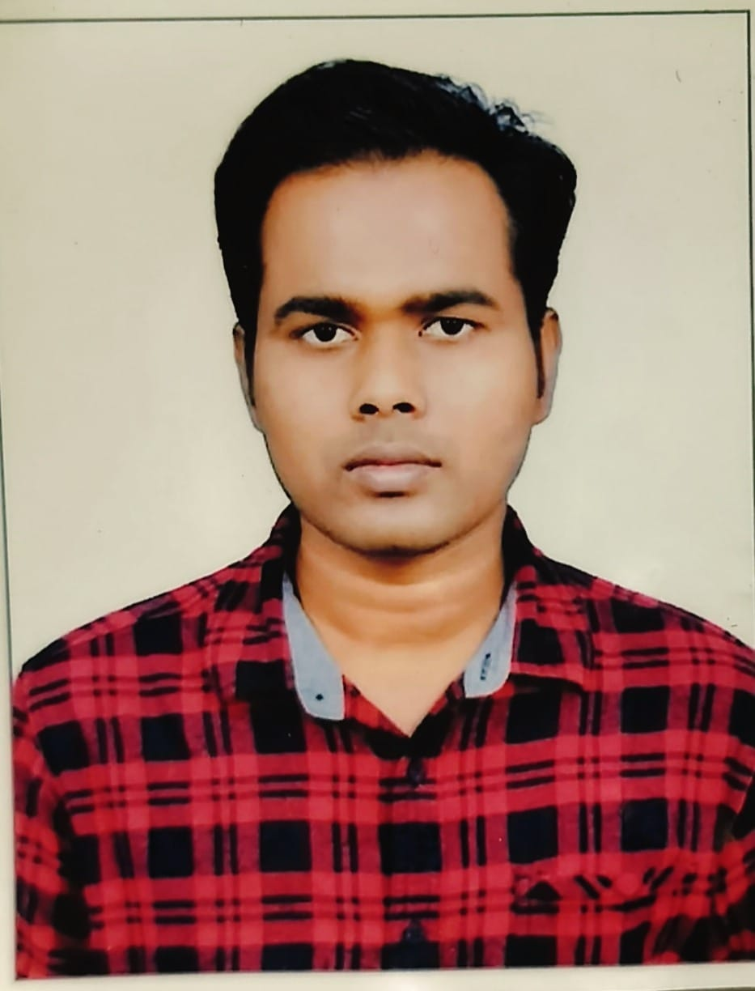

Full Name of the Candidate:(in Block Letters): DR. SAGAR MANTRY
- Category:(i) UR/ST/SC/SEBC/DA: UR
(ii)Male/Female: MALE
- Date of Birth: 01 MAY 1994
(as per H.S.C or Equivalent Examination)
- Permanent home address: AT-RAMACHANDRAPUR, P.O-DURGAPUR, VIA/P.S-
BANKI, DIST-CUTTACK, PIN-754008, ODISHA
- Present Address in full (with PIN Code): AT-RAMACHANDRAPUR,
P.O-DURGAPUR, VIA/P.S-BANKI, DIST-
CUTTACK, PIN-754008, ODISHA
- Contact Telephone/Mobile No.: 9583732718, 9583885925
- E-mail ID: sagarmantry94@gmail.com
- Whether qualified NET/SLET/SET: YES (PH.D. ONLY)
- Academic qualification:

Examination or degree passed | Passed in Regular/ Distance Mode | Name of the Board/ University | Subjects taken with Hons. &  Special paper subject | % of marks obtained | Year of passing
HSC | REGULAR | B.S.E, ORISSA | FLO,SLE,TLS,MTH,SCP,SCL,SSG,SSH | 69.33% | 2009
+2 | REGULAR | CHSE, ORISSA | ENG,MIL(ORIYA), LOG,POL.SCI.,EDN, OPT. SAN | 60.33% | 2011
+3 | REGULAR | UTKAL UNIVERSITY | SANSKRIT(HONS.) | 64.72% | 2014
PG | REGULAR | UTKAL UNIVERSITY | SANSKRIT | 73.23% | 2016
PG | REGULAR | MSCB UNIVERSITY | YOGA & NATUROPATHY | 71.30% | 2018
M.Phil. | REGULAR | SSS UNIVERSITY | A Study of Vṛtti with Special Reference to  Yoga Darśana | 61.75% | 2021
Ph.D. | REGULAR | UTKAL UNIVERSITY | A Philosophical Study on Yoga Kundalini Upanisad | PASS | 2025
YCB |  | YOGA CERTIFICATE BOARD | YOGA TEACHER & EVALUATOR | PASS | 2024
NCC | REGULAR |  | B-CERTIFICATE | PASS | 2013
PGDCA | REGULAR |  |  | 88% | 2013

10.Teaching/Research Experience

Name of Institution/Department/ Organization  Where taught | Designation | Level of course taught (+3/PG/  Pre-Ph.D.) | Subjects taught | Duration
 |  |  |  | DD/MM/YY | DD/MM/YY
 |  |  |  | From | To
Vivekananda Public School | YOGA TEACHER |  | YOGA | 06/02/2019 | 16/05/2023
MSCB UNIVERSITY | GUEST FACULTY | P.G. | Y&N | 01/06/2023 | 31/12/2023
MSCB UNIVERSITY | GUEST FACULTY | P.G. | Y&N | 02/01/2024 | 31/05/2024
MSCB UNIVERSITY | GUEST FACULTY | P.G. | Y&N | 03/06/2024 | 31/08/2024
MSCB UNIVERSITY | GUEST FACULTY | P.G. | Y&N | 11/09/2024 | 28/02/2025
MSCB UNIVERSITY | GUEST FACULTY | P.G. | Y&N | 01/03/2025 | 31/05/2025
MSCB UNIVERSITY | GUEST FACULTY | P.G. | Y&N | 02/06/2025 | 31/08/2025
MSCB UNIVERSITY | GUEST FACULTY | P.G. | Y&N | 02/09/2025 | 31/12/2025

- Research Publications (In Journals/Book/Edited Books etc.)

Sl. No | Name of Publisher Address& Web Site | Name of Journal/Book with ISSN/ISBN  Number | List of Coauthors | Volume | Page No. | Year of publication
1. | Bharatiya Kalaprakashan,Delhi-110035 & web- www.bkpbooks.com | 9788180904202 | Mr. Sagar Mantry |  | 454 | 2024
2. | Crown Publishing, Chhattisgarh-495006  web- www.crownpublising.in | 9789364266925 | Dr. Sagar Mantry  Dr. Sujata Jena |  | 259 | 2025
3. | Indu Book Services Pvt Ltd  New Delhi-110002  Web-www.indubookservices.com | 9789367293751 | Dr. Sagar Mantry  Dr. Sujata Jena |  | 214 | 2026
4. | Monica Bhandari  Web-www.monicabhandaribooks.com |  | Dr. Sagar Mantry |  | 100 | 2026
5. | Akshara Publication, Maharashtra-425201 | 2582-5429 | Sagar Mantry | 3 Issue V (A) | 114 | 2022
6. | Akshara Publication, Maharashtra-425201 | 2582-5429 | Sagar Mantry | 3 Issue VI (B) | 18 | 2022
7. | Sanskuta Sanskuti Vikasa Sanstana, Rajastana-328021 | 2454-1230 | Sagar Mantry | XVII | 206 | 2023
8. | Akshara Varta, MP-456006 | 2349-7521 | Sagar Mantry | XX, Issue-IV | 166 | 2024
9. | Sanskuta Sanskuti Vikasa Sanstana, Rajastana-328021 | 2454-1230 | Sagar Mantry | XIX | 158 | 2024
10. | IJCRT, www.ijcrt.org | 2320-2882 | Sagar Mantry | 12 Issue1 | F173 | 2024
11. | www.veterinaria.org | 1695-7504 | Sagar Mantry | 25 | 846 | 2024
12. | The Brahmi  www.thebtahmi.com | 3048-9660 | Sagar Mantry | 01 | 129 | 2024

- Dissertation/Project work carried out in PG/Ph.D. Level.

Sl.  No. | Title of  Dissertation | Name of the students | Year of submission | Result of the student
1. | Impact of Kundalini Yoga in Human Body | Anindita Nayak | 2024 | Pass
2. | Impact of game Therapy in our Daily Life | Suraj Kumar Sahu | 2024 | Pass
3. | Exploring the Role of Yoga and Naturopathy in Stress Management and Mental Health | Mrs. Ritun Mohanta | 2024 | Pass
4. | Contemporary Study on Yoga | Aishwarya Rout | 2024 | Pass
5. | A Study on Bhakti Yoga | Sasmita Mahakud | 2024 | Pass
6. | A Study on the Relevance of Yogic Diet | Pravati Jena | 2024 | Pass
7. | Impact of Meditation in Modern Age | Pravati sing | 2024 | Pass
8. | A Comparative Study of Ayurveda and Naturopathy Treatment | Julamani Das | 2024 | Pass
9. | The Scientifical effect of Chakra in human Body | Bhagyashree Mohanta | 2025 | Pass
10 | The Significance of the Bhakta and Bhakti in Hinduism | Chinmayee Mohanta | 2025 | Pass
11 | A comparative study of Samkhya’s and yoga philosophy: AN analysis of the concept of Liberation | Gayatri Mohanta | 2025 | Pass
12 | Sundara Kanda in Ramayana: A symbol of inner strength and the triumph of God | Gitanjali Mohanta | 2025 | Pass
13 | Naturopathy Treatment on Human body | Haragauri Das | 2025 | Pass
14 | Concept of Food and Nutrition in Ayurveda. | Madhusmita Dhungia | 2025 | Pass
15 | The Concept of dharma to moksha: A Holistic approach to life’s Goal | Madhusmita Mohanta | 2025 | Pass
16 | The Importance Role of Yoga in Digestive System | Monalika Parida | 2025 | Pass
17 | The Role of Autophagy in cellular homeostasis | Patitapaban Gantayata | 2025 | Pass
18 | Various Disease treatment through Ayurveda | Sunaram Murmu | 2025 | Pass
19 | Prana and Pranayama for holistic development of life | Truptimayee Mohanta | 2025 | Pass
20 | Balancing the three doshas through yoga and Naturopathy | Divya Ranjan Patra | 2025 | Pass
21 | Yogic management of bronchial Asthma | Geetishree Mohanta | 2025 | Pass
22 | The role of tri dosha in Ayurveda | Laxmipriya Mohanta | 2025 | Pass
23 | A Study of Mudras in Yoga | Mamuni Dhal | 2025 | Pass
24 | Imperative herbs from classical text of Ayurveda used in Panchakarma | Rashmita Nandi | 2025 | Pass
25 | Draupadi the embodiment of strength sacrificial and revenge in Mahabharat | Sangeeta Mohanta | 2025 | Pass
26 | The Essence of Karma Yoga Philosophy in Daily life | Shrabani Pradhan | 2025 | Pass

- Carrer Objective:
Having for a challenging career and looking for an organization that will provide me an opportunity to apply my skills, innovative ideas and experience for the advancement of the organization and my continued growth.
- Language Skills:
- Odia (read, write, speak)
- Hindi (read, write, speak)
- English (read, write, speak)
- Sanskrit (read, write, speak)
- Hobbies:
- Making Friends
- Interested Yoga, Meditation, Pranayama
- Writing
- Reading Spiritual Book
Declaration:

I hereby declare that the above-mentioned information is true to the best of my knowledge and belief.

Place: Cuttack
Date: 03/04/2026

Full Signature of Candidate

